E-Project: Movie Booking System

Movie Booking System:

|  |  |  |
| --- | --- | --- |
| **Supervisor.** | Miss Ambreen | |
| **Batch.** | 2212F1 | |
| **Group.** |  | |
| **Serial No.** | **Enrollment Number** | **Student Name** |
| 1. | Student1422580 | AROOSHA NAFEES |
| 2. | Student1428001 | AREESHA KAINAT |
| 3. | Student1428000 | ALIYAN KHAN |

***USER GUIDE***

**1.movie booking system***(index.php)*

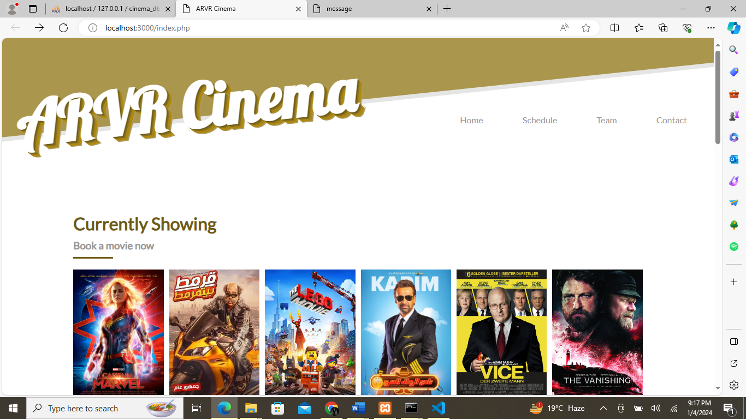

**Main Layout of movie booking system:**

That’s a home page of our website first we have a navigation bar and then we have a header. In navigation bar we have Home, Schedule, contact after this then in header we have currently showing book a movie now text and stay in touch page. This page helps you to book a seat. After that we have 3 simple steps to book a movie also you can explore new movies in this page. In the last of this page, we have footer in footer include some details to contact, social media accounts.

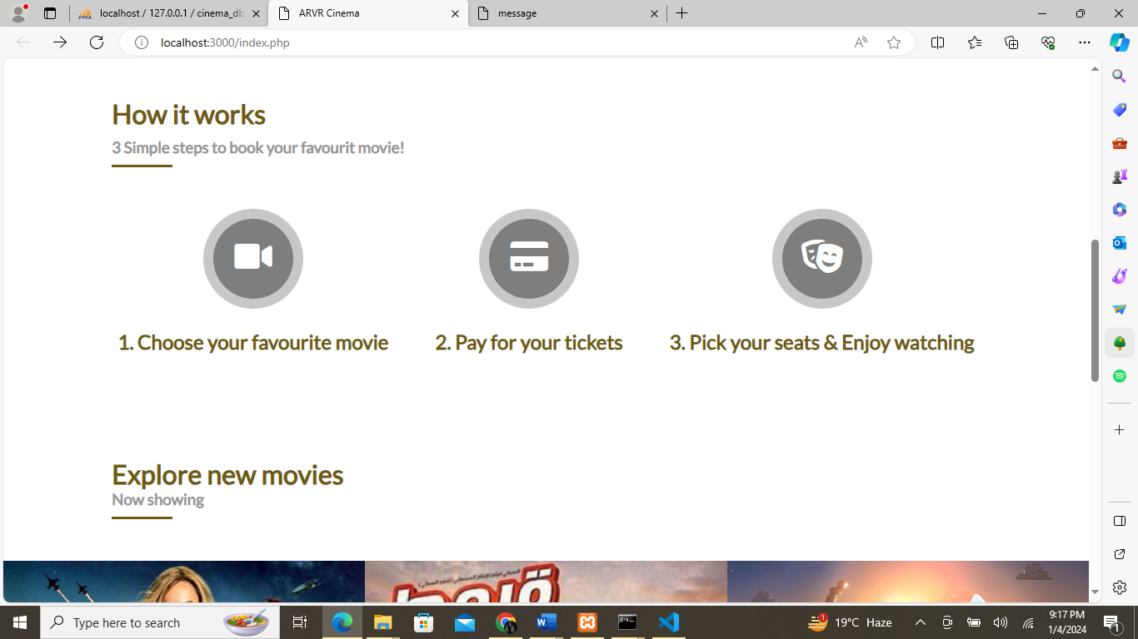

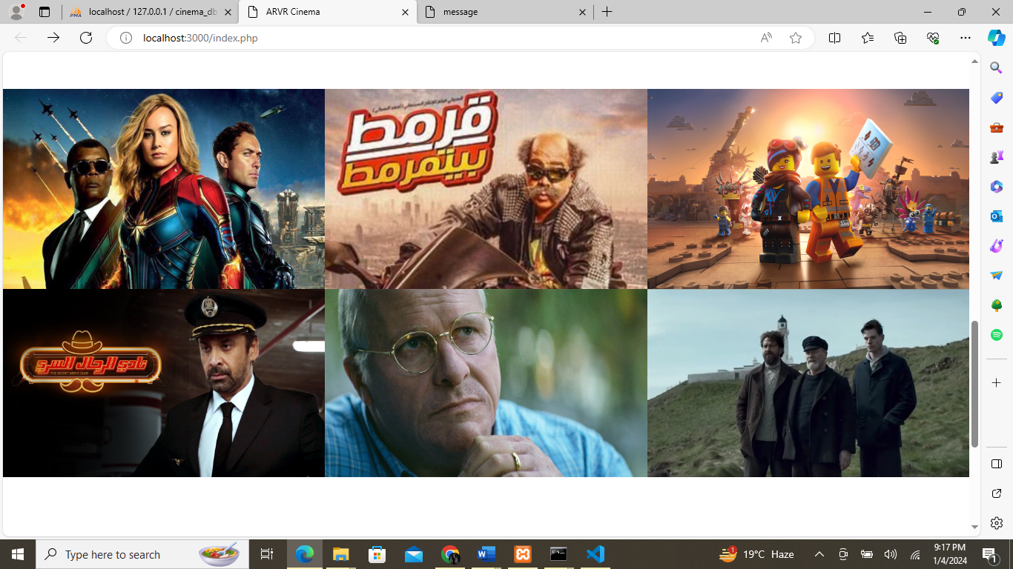

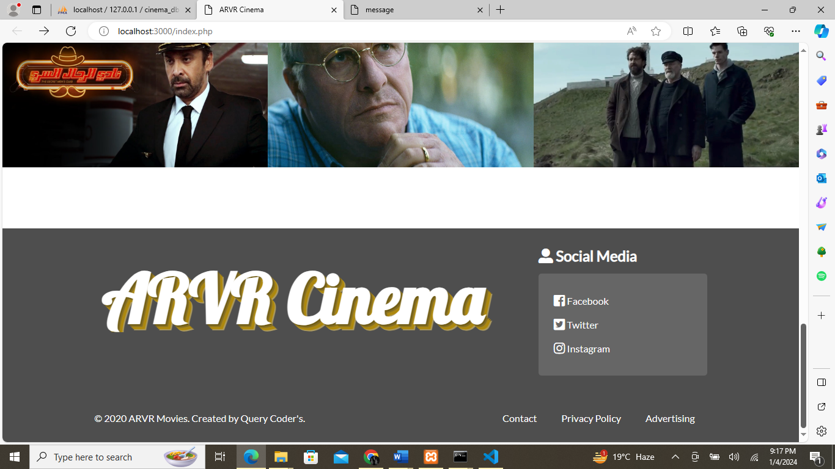

**2.Reserve Your Ticket**

**Reserve Your Ticket:**

In our home page you can book a seat button when you will click that button you can see the reserve your ticket page, where you could see all information about movie such as genre, duration, release date, director, & actors. Then we have a theatre, time, type, or date can select according to your feasibility. Then you will enter your name, email, phone number, or email. Then you will click the button of book a seat again after that click, you will be the page of proceed for payment then after the click of that button pay now you can pay for you movie ticket. This page is linked from the home page.

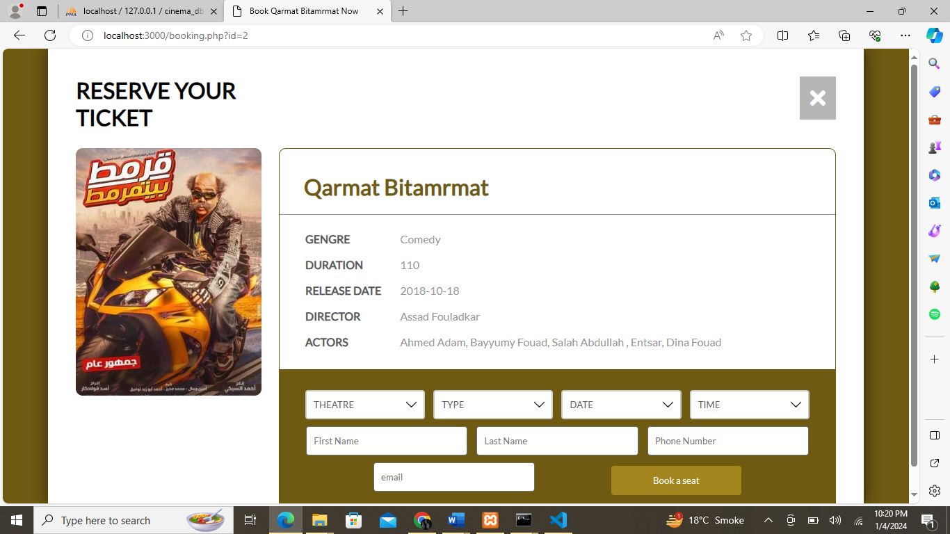

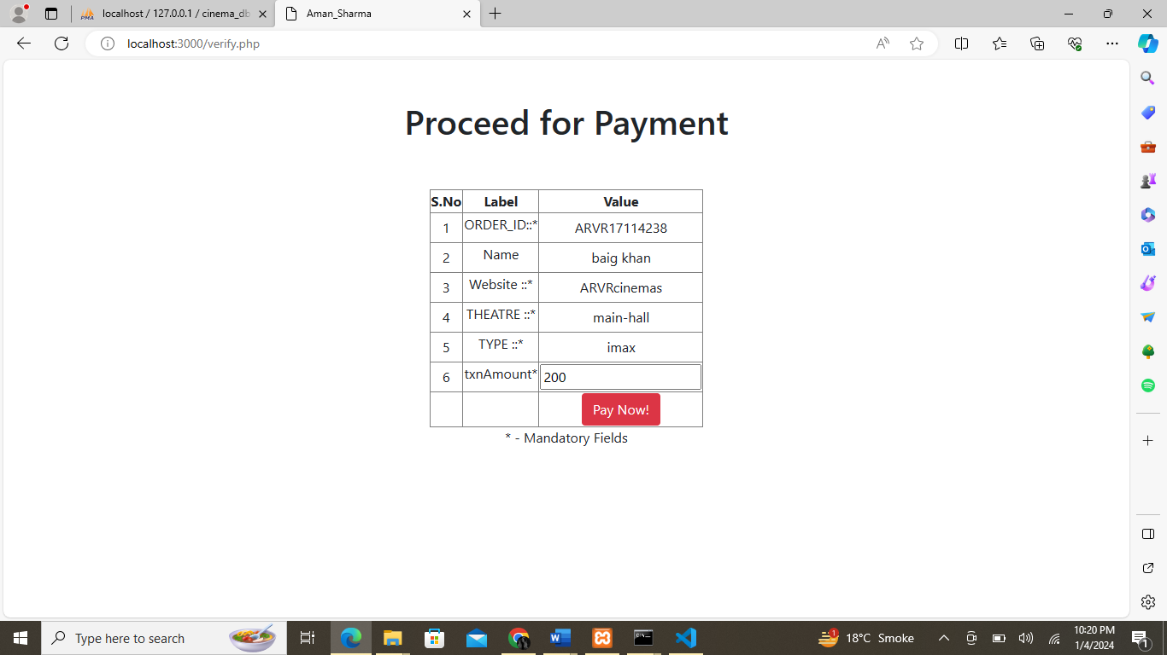

**Schedule:**

Then we have the schedule page, schedule page is the second page of or web where you can check available dates or seats also where you can see the timing of PRIVATE HALL, VIP HALL, & MAIN HALL timings. With the help of this schedule page, you can reserve a seat or ticket. Also, you can take more details from this page.

**3.Schedule**

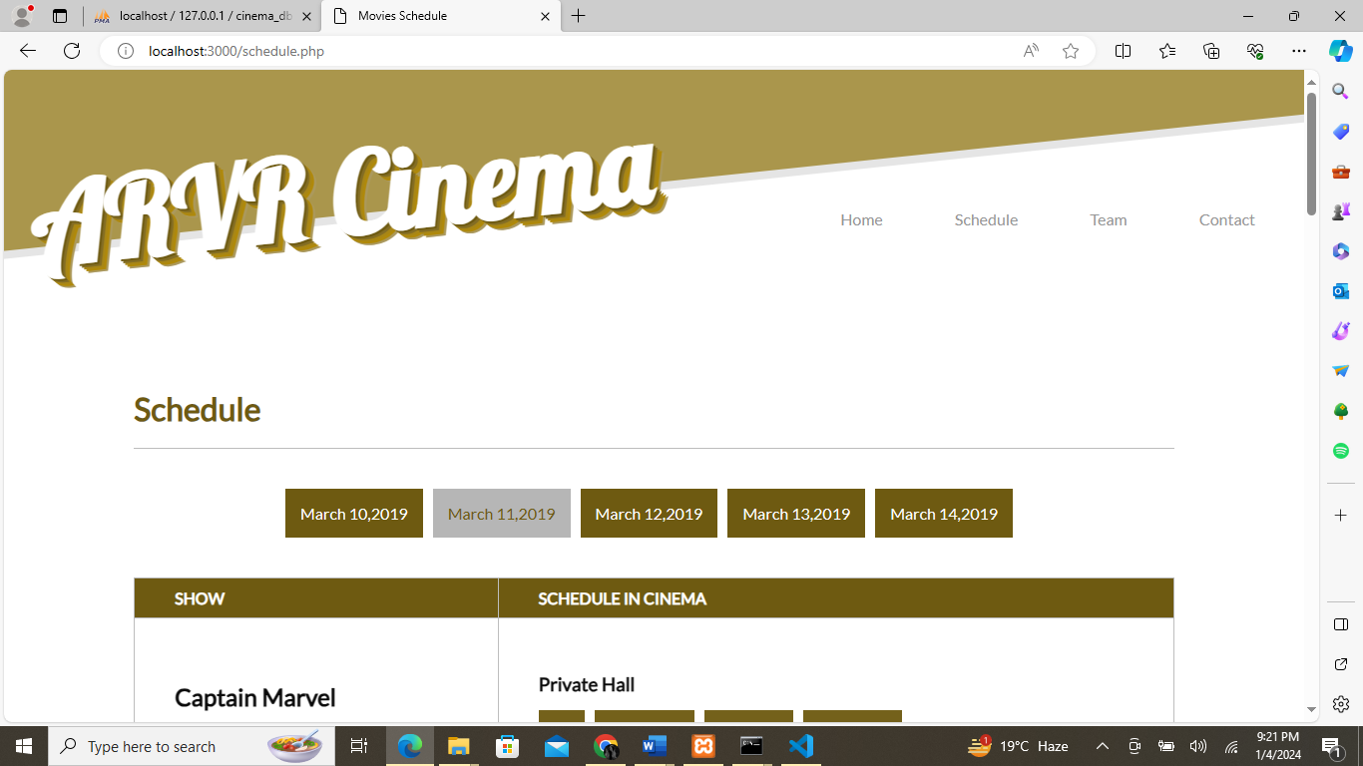

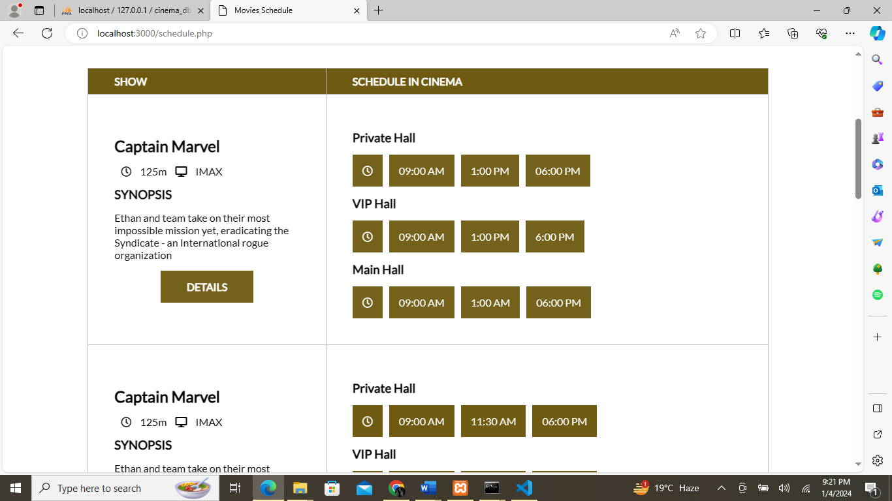

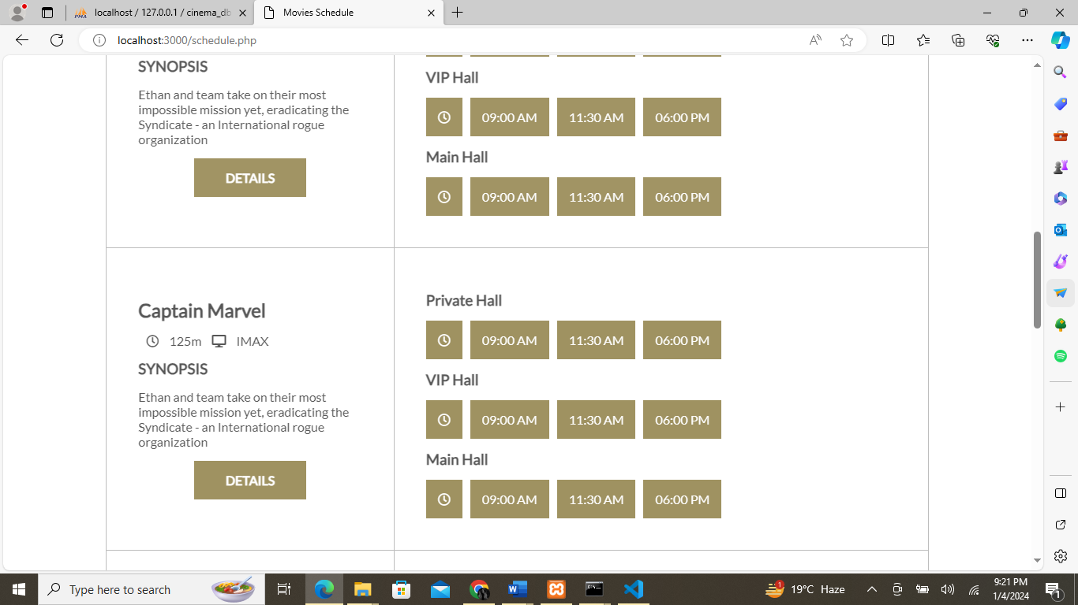

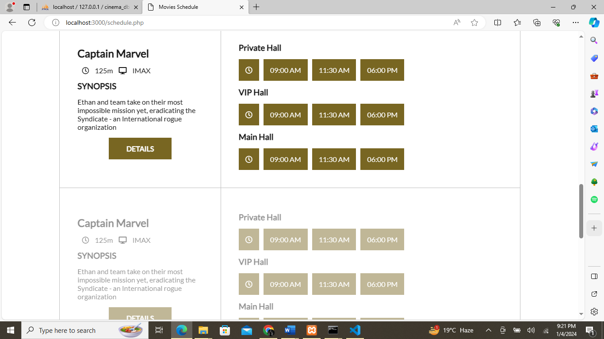

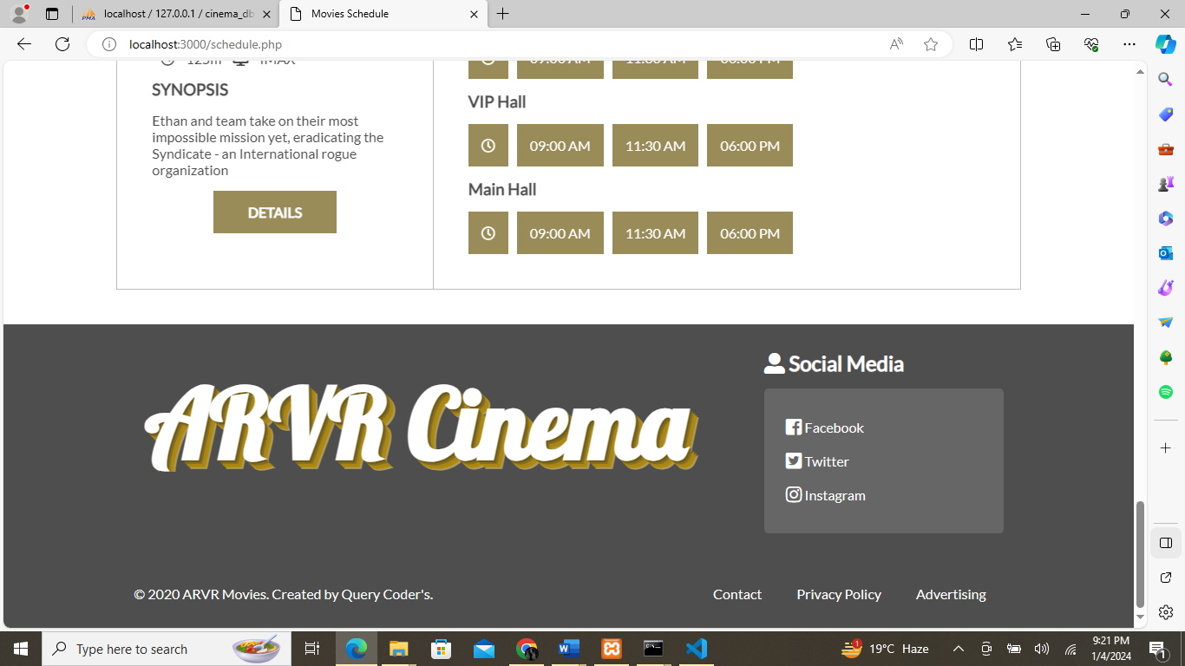

**4.Contact**

**Contact:**

Last but not the least then we have contact page where you are feeling free to contact us, we mention our contact numbers, emails, address, and then you can share your message with us. When you click the send your message button you get notification that you message successfully submitted.

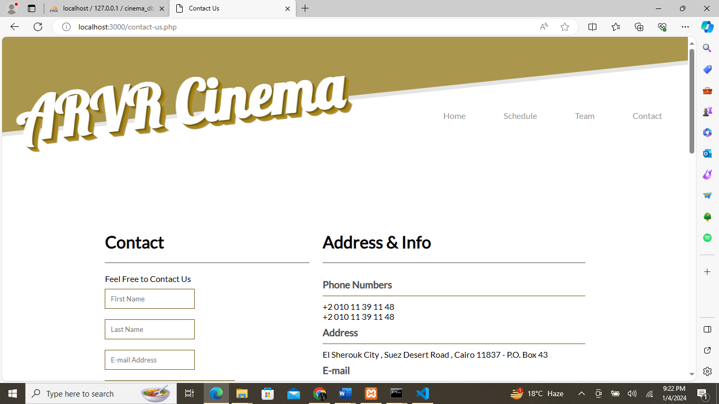

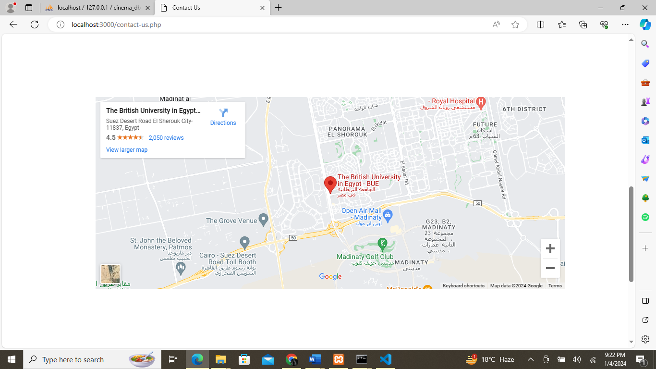

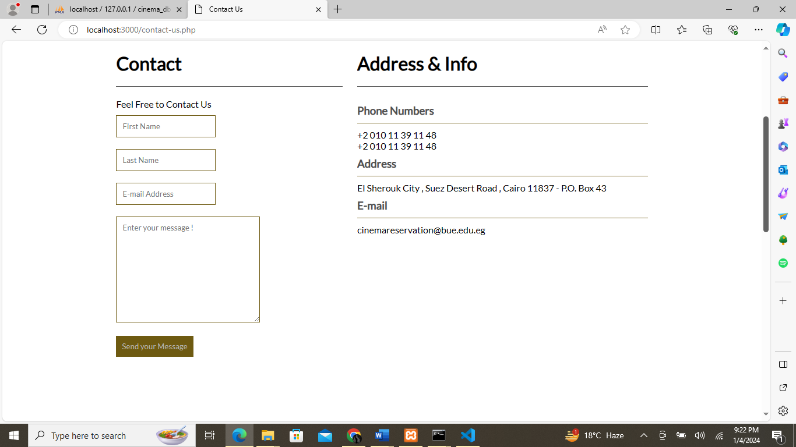

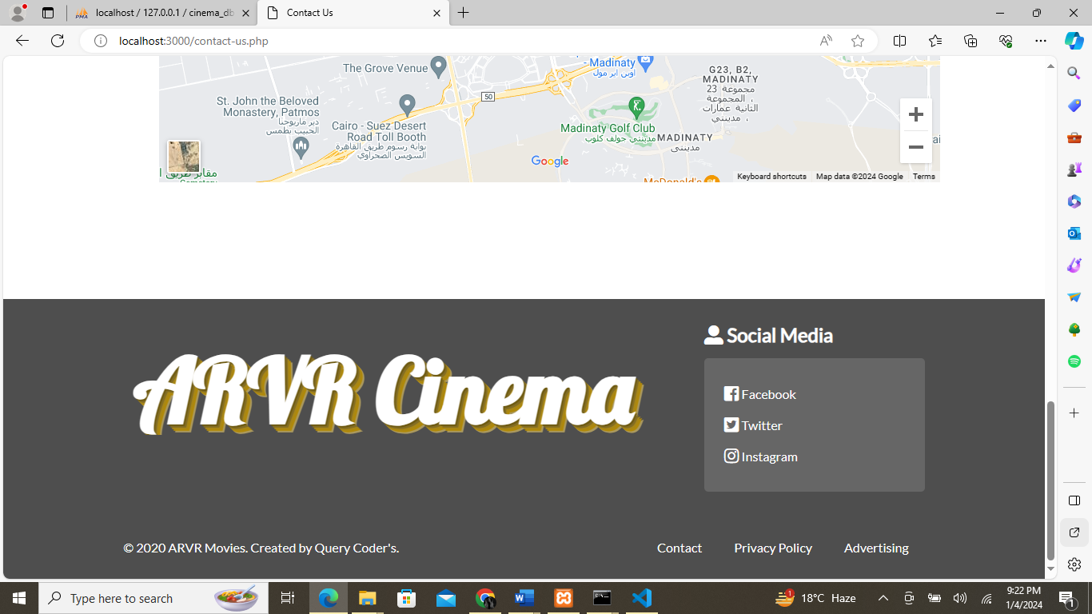

**Thank You For Reading The Documentation.**

**Please Follow The Instructions Above!!**